Adding and Replacing Diagram Reports in Enterprise Architect

# How to Replace Diagram Reports in Diagrams that already have report links:

1. First of all, ensure that the new diagram reports have been generated and that you have access to them. There are separate instructions for how to do the report generation.
2. In EA, open the diagram where you want to replace an old report with a new one. Click on the “Double-click here to download *<diagram name>* Diagram Metadata” to open up the internal file. Delete all rows.
3. Open the folder in Github (or on your laptop) that contains the new reports. Open the file that contains the new report. Copy and paste (using “Paste Special - keep source column widths”) all rows to the blank internal file that you just deleted all the records from. This approach retains the label on the diagram as it is and the object doesn’t have to be renamed and re-formatted. This saves a lot of time when you have 30+ diagrams to process.
4. Save the file. Exit Excel.
5. Go back to EA. Click “Save” when it asks you. See screen shot below to see what the window in EA looks like.

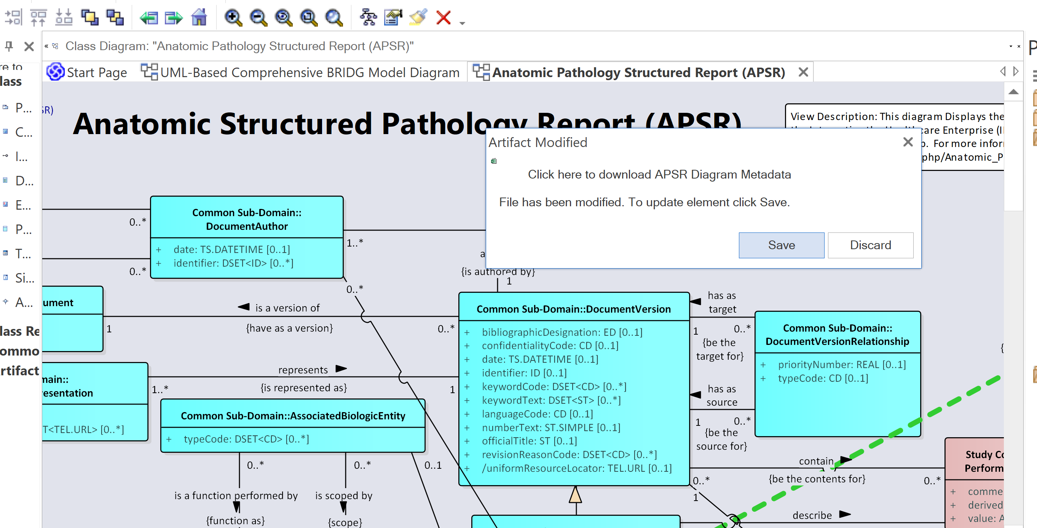

# How to add a Diagram Report to a Diagram for the first time

1. First of all, ensure that the new diagram reports have been generated and that you have access to them. There are separate instructions for how to do the report generation.
2. In EA, open the diagram where you want to add a diagram report.
3. Open the folder in Github (or on your laptop) that contains the new reports. Drag the file of the report that you want to the diagram. You can now change the artifact name to ““Double-click here to download *<diagram name>* Diagram Metadata” and format the object. Follow the naming convention and formatting from diagrams that already have a diagram report link.